 **ROOM RESERVATION FORM**

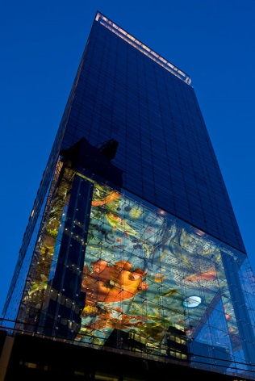

**“GLOBALDATA UK –**

**Fire Protection of Rolling Stock Conference”**

**February 24 to 26, 2025**

**Guest Details**

Family Name  Company Name 

First Name  Country 

E-Mail  Business/Mobil 

EUR 240,00 single occupancy

EUR 270,00 double occupancy

all prices are per room, per night, including taxes and breakfast

Number of person(s) in room 1 person Check-in date, Monday, February 24, 2025

 Check-out date, Wednesday, February 26, 2025

Special requirements 

**Cancellation policy**

Cancellation and/or amendments are free of charge up to 7 days prior to the arrival date. Cancellation and/or amendments made after that time will be charged to your credit card at the total cost of the stay.

**Credit Card Details**

Please note that the mentioned credit card is used only as a guarantee of the reservation and the guest subsequently pays his/her bill upon departure.

Credit Card Details & Invoice Header  

Name on Card  

Number  

Expiry Date  

Please charge the above credit card for the cost of accomodation and breakfast upon departure of the guest(s)

with the above invoice header

I wish to receive the invoice via email

**Please complete and return this form until January 24, 2025 at the latest.**

Contact details of hotel and for questions / returning the form

SO/ Vienna

Philippe Glaser

Reservations Manager

Tel +43 1 90 616 6105

E-Mail philippe.glaser@so-hotels.com

Website www.so-vienna.com